Amazon MQ
What is Amazon MQ?
Amazon MQ is a managed message broker service provided by AWS.
It allows different applications to send, receive, and exchange messages reliably without directly communicating with each other.
AWS manages the broker, so you don't have to install, patch, monitor, or maintain messaging software.
Simple Definition (Interview)
Amazon MQ is a fully managed message broker service that enables applications to communicate asynchronously using industry-standard messaging protocols such as JMS, AMQP, MQTT, STOMP, and OpenWire.

What is a Message Broker?
A message broker acts like a middleman between applications.
Instead of Application A talking directly to Application B, both communicate through the broker.
Without Amazon MQ
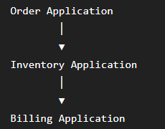
Problems:
- Applications are tightly coupled.
- If one application is down, communication may fail.
With Amazon MQ
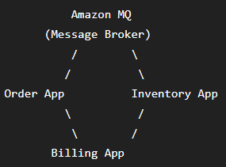
Applications send messages to Amazon MQ, and MQ delivers them to the appropriate application.

Why Do We Need Amazon MQ?
Imagine an online shopping application.
When a customer places an order, several tasks must happen:
- Send confirmation email
- Update inventory
- Generate invoice
- Notify shipping
Without a message broker:
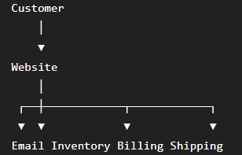
If one service is slow or unavailable, the website may be delayed.

With Amazon MQ:
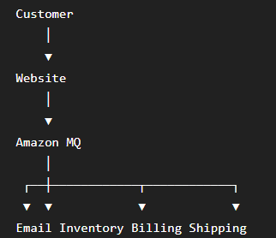
The website only sends one message to Amazon MQ.
Each service processes the message independently.

Real-Time Example
Suppose Amazon receives an order.
Customer buys a laptop.
Order ID:1001
Laptop
₹65000
Website sends this message to Amazon MQ.
Amazon MQ stores it.
Inventory Application receives it.
Billing Application receives it.
Email Application receives it.
Shipping Application receives it.
Every application works independently.

Where is Amazon MQ Used?
Amazon MQ is commonly used in:
- Banking systems
- E-commerce websites
- Insurance applications
- Healthcare systems
- Logistics companies
- Airline reservation systems
- Enterprise Java applications

Supported Message Broker Engines
Amazon MQ supports two broker engines.
Broker | Use Case
ActiveMQ | Enterprise applications, JMS-based systems
RabbitMQ | Modern microservices, lightweight messaging

Amazon MQ Features
- Fully managed by AWS
- High availability
- Automatic backups
- Encryption
- Monitoring with CloudWatch
- Supports multiple messaging protocols
- Easy scaling

Advantages
✅ No server management
✅ Reliable message delivery
✅ High availability
✅ Secure communication
✅ Easy migration of existing applications

Disadvantages
❌ More expensive than Amazon SQS
❌ Requires broker management concepts
❌ Not serverless

Amazon MQ vs Amazon SQS
Amazon MQ | Amazon SQS
Managed message broker | Managed message queue
Supports JMS, AMQP, MQTT, STOMP | AWS proprietary API
Best for legacy enterprise applications | Best for cloud-native/serverless applications
Applications connect to the broker | Applications read/write directly to the queue
Stateful | Serverless and highly scalable

Step 1: Create a Broker
- AWS Console → Amazon MQ
- Click Create broker
Configure:
Setting | Value
Broker Name | DemoBroker
Deployment Mode | Single-instance Broker
Broker Engine | ActiveMQ
Engine Version | Latest
Instance Type | mq.t3.micro(Free Tier if available)

Step 2: Create User
Under Broker users
Username
admin
Password
Password@123
Click Create broker.
⏳ Wait 10–20 minutes until the status becomes Running.
Screenshot: Broker Status = Running 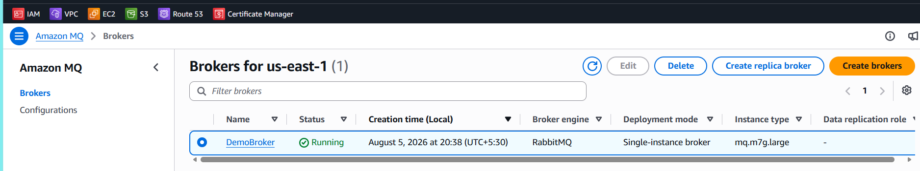

Step 3: Verify Broker Status
Open the broker.
You should see:
Broker Status

Running
Screenshot: Broker Status
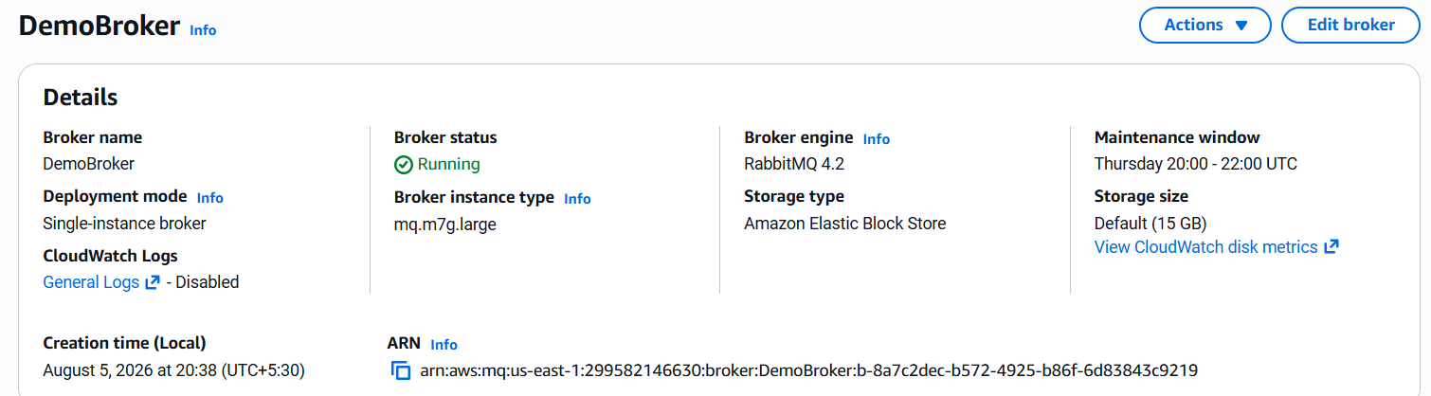

Step 4: View Connection Endpoints
Open
Connections
You will find something similar to:
SSL Endpoint
ssl://b-xxxxxxxx.mq.us-east-1.amazonaws.com:61617
or
OpenWire
ssl://xxxxxxxx:61617
Screenshot: Connection Endpoints
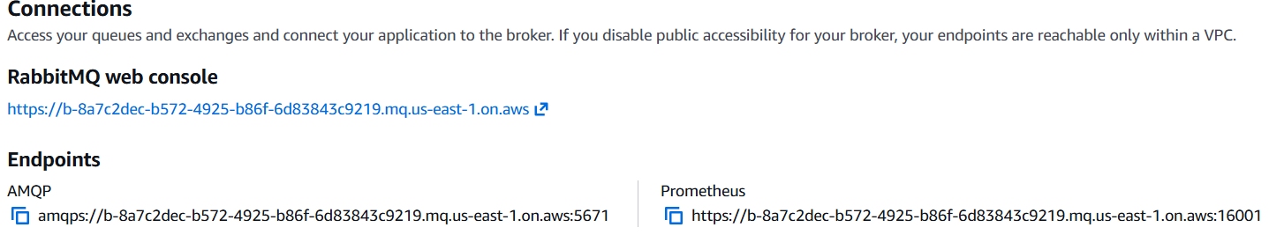

Where Applications Connect
Applications (Java, Spring Boot, Python, .NET, etc.) connect to the Amazon MQ endpoint using:
- Broker endpoint (hostname)
- Port
- Username
- Pasword

Example:
Application
│
▼
Endpoint:
ssl://b-abc123.mq.us-east-1.amazonaws.com:61617
Username: admin
Password: ********
Applications send and receive messages through this endpoint.

Observations
- Successfully created an Amazon MQ broker.
- Broker status changed to Running.
- Verified broker connection endpoints.
- Understood that client applications connect using the endpoint, username, and password.

